11776 3rd Street SE
Cooperstown, ND 58425
Phone: 701-581-6921
mail@cbcnd.com
www.cbcnd.com

IMPORTANT INFORMATION:
We’re looking forward to an exciting summer. The staff at Cooperstown Bible Camp is anxiously awaiting the arrival of all the campers. We anticipate the wonderful things God has planned at CBC this summer for all our campers. Please review the following important information you will need to know.

PAYMENT DETAILS:
If you have a balance, you can pay by logging into your account at
www.ultracamp.com.
Or pay by mailing a check (with notation) to:
Cooperstown Bible Camp
11776 3rd Street SE
Cooperstown, ND 58425
You can also complete payments at Monday morning check-in.

CHECK-IN:
Check-in for all summer youth camps begins Monday at 10 am. Check-in will take place in the lodge.

MEDICAL NEEDS:
Please bring all prescription and over-the-counter medications (in the original prescription bottle) in a gallon
Ziploc bag labeled with camper’s name to registration. Please include original and detailed instructions for the
Camp Nurse for all medical needs. Upon arrival we will have all parents or guardians check in with our nurse to go over any special instructions and needs for your camper

CAMP PICTURES:
Camp photos are available for $7.00, and can be ordered online, by phone, or at check-in. They will
NOT be available until check out at the end of the Camp Week. We ask that you please make sure to pick up your photos at check out.

CAMP STORE:
Campers can purchase a variety of items at the CBC camp store. The store is fully stocked with snacks, sodas, CBC apparel, water bottles, small toys, gifts for Mom and Dad, and much more! The store will be open periodically throughout the camp week. We suggest $25 for spending money, if you decide to send your camper with money for the store it needs to be put in a baggy and labeled “Store” so that at registration we can make sure it gets added to the camper’s store account. We DO NOT allow campers to carry money on them throughout the week.

SEND YOUR CAMPER A LETTER;
We love to give campers mail during their week at CBC. You can write your camper a letter or send a box of goodies. To insure that letters make it to your camper on time we advise sending them the Monday of the week they will be here, or you can have them all prepared and give them to us at check in. You can also send an email by signing into your account in the Ultracamp portal and clicking “send my camper an email.” Friday is our last mail deliver so please send all emails before 4:00 pm on Friday. Mail is handed out each day at our session.

WHAT TO BRING:

Clothing: Clothes, which can get dirty, sportswear, jeans, modest one-piece swimsuit, warm weather
clothes, and comfortable shoes (If your camper wants to do the rock wall or high ropes, they will need a pair of closed toe shoes). Please clearly mark clothing. Modesty of dress is expected. Shorts must be no more than (6) inches above the top of the knee cap. Shorts not meeting length guidelines require appropriate spandex underneath. (No halter tops, or tube tops, or overly tight-fitting clothing, please

Bedding: Pillow and a sleeping bag. (Sheets and two blankets are acceptable.)

Personal: Towels (one for shower, one for pool), washcloth, soap, shampoo and conditioner, toothbrush and
toothpaste, deodorant, and other toiletries. Notebook, pen or pencil, Bible, flashlight, insect repellent
& Sunscreen. Water Bottle!! (If you do not have a water bottle you can send, one can be purchased from the camp store for $1.50)

Spending money: For camp store. All campers deposit their money in the camp bank
when they register. Your camper’s money is available to them daily. Money not spent will be donated to the Camps scholarship fund. There will be a chance after check-out for parents and campers to spend the rest of the remaining balance if any. There will be NO refunds for remaining store money.

WHAT TO LEAVE AT HOME:
Music equipment, expensive small items, toys, cell phones, iPods & MP3 players, handheld games and computers, knives, fireworks, alcohol, tobacco, cigarettes, firearms, food, and candy. If Senior High campers drive to camp, they must turn in their keys at registration and will not be allowed to drive anytime throughout the week.

PICKING UP YOUR CAMPER:
When you come to pick up your camper(s) on Saturday (Thursday for Early Bird Camp), Chapel is at 9:00 a.m. and checkout is at 10:00 a.m. Parents are expected to join their campers in the 9:00 a.m. Chapel service. We ask that when parents or guardians arrive at camp that they either stay in their vehicle until 9:00am or head to the Tabernacle, NOT the lodge. After Chapel campers will go back to their cabins with their counselors and parents will go to the lodge to check campers out. ONLY those specified on ultra-camp for pick up may check out a camper. After you have checked out your camper you will then head to their cabin and pick them up and their belongings (medications will have been returned to them by the nurse earlier that day). The camp store will be open during check out, this will be the last chance to spend the remaining balance your camper may have, we ask that you keep your camper with you once you have picked them up from their cabin. Camp photos can be picked up during check out.

LOST AND FOUND:
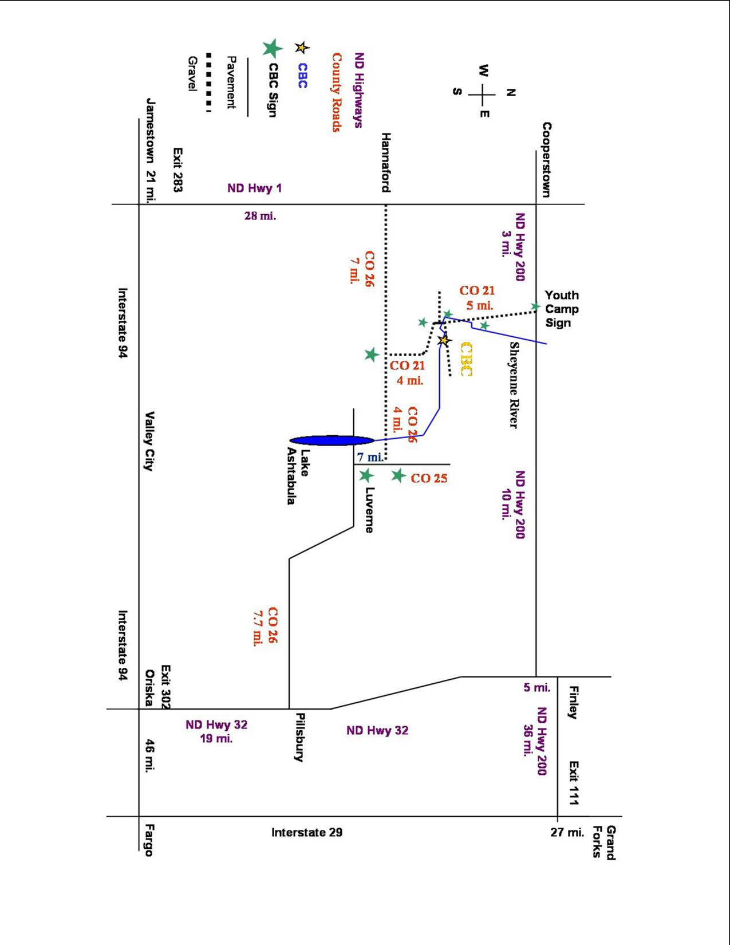
If your camper is missing anything you can check the Lost & Found table at The Lodge before you leave. If anything else is lost CBC will hold onto all lost and found for two weeks then items will be thrown out – check for your camper’s things even if they say they didn’t forget anything!

CANCELLATION POLICY:
In the event of a medical emergency where a camper will not be able to attend his/her camp, registration fees
will be refunded, except for a $30 non-refundable registration fee. For non-emergency reasons, refunds will be
given up to 14 days prior to the camper’s chosen week, except for a $30 non-refundable registration fee. If your camper is Sick, please do not send them to camp.

QUESTIONS:
If you have any questions call or e-mail us at:
701-581-6921
mail@cbcnd.com

